EMBARGOED UNTIL 0900hrs (CET) 28th November 2012
adidas challenges fans to ‘Find Fast’ with adizero f50 mobile app
Game engages fans with leader board and exclusive prizes

Herzogenaurach, 28th November 2012 – Today, adidas football have proudly launched their latest mobile gaming app to promote the forthcoming release of the next generation adizero™ f50 boot. From today, football fans can download the exclusive ‘f50 Game’ app via the Apple Appstore or Google Play, unlocking unique adidas content which includes a game, 360˚product tour and other f50-related experiences.

As the new adizero™ f50 boot helps players to ‘Find Fast’, the main focus of the gaming experience revolves around completing tasks within the quickest time possible. The game challenges players to study selected images of adidas sponsored footballers and pick where on the image the real ball is placed from three possible alternatives. After each game, players can post their best times onto a global leader board and compare themselves against friends using Facebook Connect. Those who post the fastest times will have the chance to win unique prizes including a pair adizero™ f50 boots signed by the World’s best player, Leo Messi.

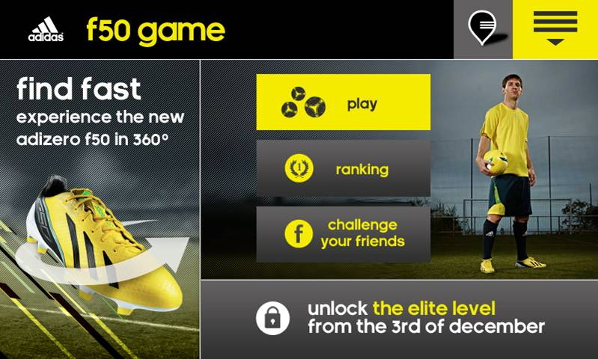
adidas ‘f50 Game’ mobile phone app

For the last few weeks, some of the most exciting professional players in the world, including Leo Messi, Dani Alves, Karim Benzema, David Silva and David Villa have dominated the game wearing the new adizero™ f50 and fans can take a 360˚ product tour within the app, providing the ability to manipulate and explore a 3D version of the new boot. Fans can share the virtual boot on Facebook and Twitter, as well as buy the real thing online through the app from Monday 3rd December. On the same date fans will be able to visit their local adidas retailer, scan f50 posters utilising the app and unlock a secret Elite Level of the gaming experience.

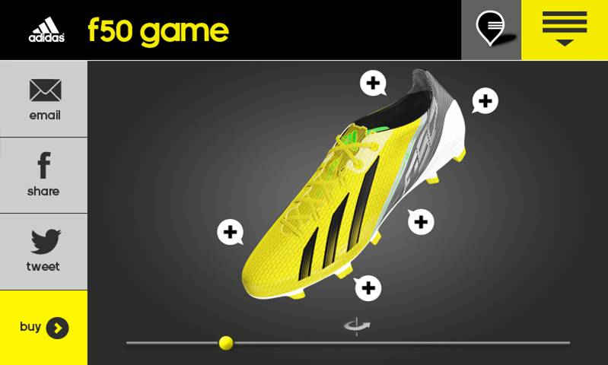
adidas ‘f50 Game’ mobile phone app

The new adizero™ f50 combines revolutionary technologies with cutting edge engineering in order to create the latest incarnation of the hugely successful silo series. SPRINTSKIN™ is a 1.5mm thick synthetic layer that allows the boot to be lightweight whilst maintaining a natural feeling between boot and ball. SPRINTWEB is the 3D printed texture on the surface of the boot that allows for exceptional ball control at speed and also provides the supple but stable construction. The final layer of boot construction is the SPRINTFRAME, a strong but lightweight lower section that offers players a perfectly balanced boot.

Leo Messi test drives the new adidas ‘f50 Game’ mobile phone app

‘f50 Game’ is now available for free download in both Apple Appstore and Google Play. The new adizero™ f50 boots will be available at adidas own-retail outlets as well as specialist stores worldwide from Monday 3rd December 2012 in Vivid Yellow / Black / Green Zest. For further information please visit adidas.com/football or go to facebook.com/adidasfootball or @adidasfootball on twitter to join the conversation.

Stockists: Apple Appstore and Google Play
RRP: free
- END –

For further information please contact:
Robert Hughes
adidas Global Football PR Manager
Email: robert.hughes@adidas.com
Tel: +49/9132/84-6856

Alan McGarrie
adidas Global Football PR Manager
Email: alan.mcgarrie@adidas.com
Tel: +49/9132/84-4686

