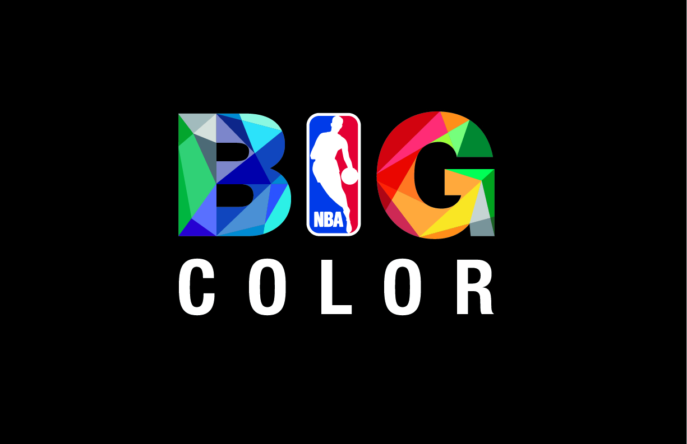

NBA AND ADIDAS TO UNVEIL “BIG COLOR” UNIFORMS FOR

CHRISTMAS DAY GAMES

- First-Ever Holiday Uniforms Featuring Bold Color to Be Worn By All 10 Teams Competing on Dec. 25-

NEW YORK (November 12, 2012) – The National Basketball Association (NBA) and its official oncourt apparel partner adidas will celebrate 65 years of Christmas Day games in a BIG way with the unveiling of special “BIG Color” uniforms that all 10 teams will wear on Dec. 25.

“I grew up watching games on Christmas Day and it’s a huge honor to have your team play in front of millions around the world,” said All-NBA center Dwight Howard of the Los Angeles Lakers. “I’m excited to wear these BIG Color uniforms that bring style and flare to the court.”

The uniforms feature a monochromatic color scheme with solid color team logos, names, and numbers framed with minimal accent color and a shimmer finish for a bold statement.

“We worked with adidas to amplify our long-standing tradition of playing on Christmas Day,” said NBA Executive Vice President Global Merchandising Sal LaRocca. “BIG Color gives our players an enhanced look on the court and highlights one of the most visible dates during our season with a new and exciting range of products.”

BIG Color jerseys are part of the adidas Winter Court Collection, which also includes new warm-up jackets and shooting shirts. The jackets feature a tricot liner for comfort and team accent colors around the team logo and name while the shooting shirt features the team practice logo on the front in accent colors. Fans can purchase the Winter Court Collection for all NBA teams at NBAStore.com, the NBA Store on Fifth Avenue in New York City, Champs Sports, and team retailers on Nov. 15.

Broadcast
ABC and ESPN will combine to present a five-game holiday blockbuster schedule, headlined by an ABC doubleheader featuring the Miami Heat hosting the Oklahoma City Thunder in an NBA Finals rematch at 5:30 p.m. ET.

Time (ET) Game Network
12 p.m. Boston Celtics at Brooklyn Nets ESPN, ESPN Mobile TV, WatchESPN
3 p.m. New York Knicks at L.A. Lakers ABC
5:30 p.m. Oklahoma City Thunder at Miami Heat ABC
8 p.m. Houston Rockets at Chicago Bulls ESPN, ESPN Mobile TV, WatchESPN
10:30 p.m. Denver Nuggets at L.A. Clippers ESPN, ESPN Mobile TV, WatchESPN

About NBA
The NBA is a global sports and media business that features three professional sports leagues: the National Basketball Association, the Women’s National Basketball Association, and the NBA Development League. The league has established a major international presence, with offices in 15 markets worldwide, games and programming in 215 countries and territories in 47 languages, and NBA merchandise for sale in more than 125,000 stores in 100 countries on six continents. End-of-season 2011-12 NBA rosters featured 78 international players from 39 countries and territories. The NBA’s digital assets include NBA TV, which is available in nearly 60 million U.S. homes, and NBA.com, which averages more than 42 million page views per day, more than half of which originate from outside of North America. The NBA is the No. 1 professional sports league on social media, with more than 300 million fans and followers globally across all league, team, and player platforms. Through NBA Cares, the league and its teams and players have donated more than $205 million to charity, completed more than 2.1 million hours of hands-on community service, and created more than 750 places where kids and families can live, learn, or play.

About adidas
adidas has been providing innovative products for the world’s best athletes for more than 50 years, from past legends to today’s superstars, such as Derrick Rose, Dwight Howard and Candace Parker. On April 11, 2006 adidas and the National Basketball Association signed an 11-year global merchandising partnership making the adidas brand the official uniform and apparel provider for the NBA, the Women’s National Basketball Association (WNBA) and the NBA Development League (D-League) beginning with the 2006-07 NBA season.

# # #

For more information, visit news.adidas.com, adidas Basketball Facebook page, www.adidasbasketball.com or contact:

Amanda Thorn, NBA Paul Jackiewicz, adidas PR
(o) 212-407-8477 (o) 971-234-2357
(m) 914-282-0257 (m) 503-593-5316
athorn@nba.com paul.jackiewicz@adidas.com

