adidas presents the new lightweight adizero Feather 2

Herzogenaurach, July 2012 – Right before the world’s best athletes come together for the London 2012 Olympic Games, adidas is launching the adizero Feather 2, the lightest everyday running shoe, to help athletes all around the world become faster and improve their performance.

miCoach SPEED_CELL
The adizero Feather 2 now features a miCoach cavity embedded in the shoe which allows the runner to insert the new miCoach SPEED_CELL™. It records up to eight hours of performance data, including distance, speed, pace, time, number of sprints, as well as time and distance in speed zones, and provides personal data to share, compare and challenge with friends.

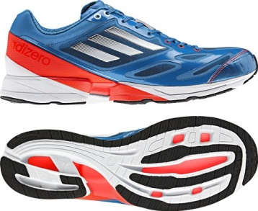
adizero Feather 2 (men’s)
On a technology side, the adizero Feather 2 features the SPRINTFRAME platform directly attached to the upper which ensures optimum forefoot propulsion. It significantly saves shoe weight while maintaining important performance characteristics, such as comfort and energy transfer. Fully integrated in the SPRINTFRAME platform is the TORSION SYSTEM which allows independent movement of fore- and rearfoot.

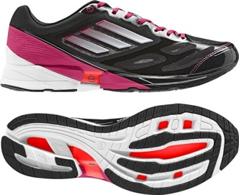
adizero Feather 2 (women’s)
The shoe also contains SPRINTWEB, a lightweight mesh construction achieved through strong seamlessly bonded TPU material for maximum comfort, support and breathability. Other technological features are full forefoot adiPRENE®+, the adiWEAR rubber outsole which ensures long-lasting durability and traction, and strategic foam placement on the sole which allows for a dynamic push-off while minimizing the overall shoe weight.

The technology and performance benefits of the adizero Feather 2 can also be found in the adizero Prime, the lightweight sprint spike (3.5oz./99g, men’s, size UK 8.5), which will be worn by adidas athletes including Yohan Blake, Jessica Ennis and Tyson Gay at the London 2012 Olympic Games taking place from July 27 to August 12, 2012.

Weighing 6.7oz./190g (men’s, size UK 8.5) and 5.6oz./160g (women’s, size UK 5.5) respectively, the adizero Feather 2 for both men and women is available as of July 2012 at selected retailers, adidas Sport Performance Stores and on www.shopadidas.com.

***

For more information on adidas Running, please visit www.adidas.com/running, our social media news room www.news.adidas.com or follow us on www.facebook.com/adidasrunning.

About adidas
adidas is a global designer, developer and marketer of athletic footwear, apparel and accessories with the mission to be the leading sports brand in the world. Brand adidas is part of the adidas Group, a corporation that includes brands such as Reebok, TaylorMade and Rockport.

About the adidas Group
The adidas Group is one of the global leaders within the sporting goods industry, offering a broad range of products around the core brands adidas, Reebok, TaylorMade, Rockport and Reebok-CCM Hockey. Headquartered in Herzogenaurach, Germany, the Group has more than 46,000 employees and generated sales of € 13.3 billion in 2011.

***

