adizero Crazy Light 2
THE FACTS
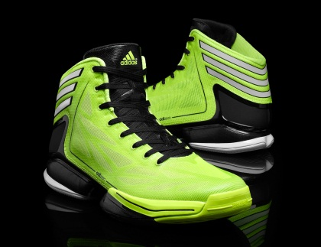
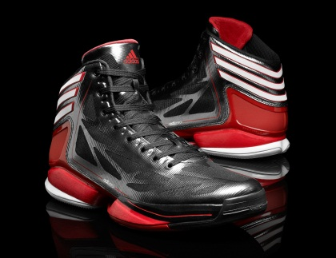

LIGHTER | At 9.5 ounces, the adizero Crazy Light 2 is the lightest basketball shoe on the planet. The latest adidas basketball innovation weighs nearly 10 percent less than the nearest competitor.  Today, adizero continues to provide the lightest in performance footwear with lightweight shoes for basketball (adizero Crazy Light 2), football (adizero 5-Star), soccer (adizero f50), baseball (adizero 5-tool), every-day running (adizero Feather and adizero Rush), sprinting (adizero Prime track spikes).
LIGHTER  DONE  STRONGER | The web layout provides both vertical and horizontal strength with the shoe’s new aerodynamic 3-layer SPRINTWEB.  adidas maximized overall shoe support, weight savings, energy return and motion control with the new asymmetrical and enlarged SPRINTFRAME.  To battle wear and tear on indoor or outdoor courts, the new lightweight toe bumper features a raised, high-abrasion rubber material.
OUTSOLE  STRENGTH &  TRACTION | To support players when making extreme v-cuts, the shoe features longitudinal grooves in the forefoot and heel.  A new multilevel cross-section increases surface area and limits dust build-up.  To reduce weight while maintaining durability, the shoe features varying rubber thicknesses along the high-wear perimeter zones.  To limit ankle rollover, the shoe features an asymmetrical midsole layout.
LIGHTER DONE BRIGHTER | The “electricity” colorway (featured above) debuted at the 2012 McDonald’s All American High School Games in Chicago on March 28.  Five colorways will go on sale May 24, including the electricity colorway seen at the McDonald’s All American Games, along with a metallic finished black/white/red (also featured above), and three others.  More colorways will drop in July and throughout 2012.
LIGHTER DONE SMARTER | The adizero Crazy Light 2 also features a micoach speed_cell™ capability, helping players measure, view and share their stats; including: time, distance, speed, speed zones and number of sprints.  Able to capture 360-degree movement and measure performance metrics during practice or gameplay, micoach technology includes an advanced accelerometer.  micoach wirelessly syncs with the user’s smartphone and uploads performance stats. The chip’s unique on-board memory stores up to seven hours of data that can be shared on Facebook and Twitter.
AVAILABLE | The adizero Crazy Light 2 ($140) will be available May 24 at adidas.com and at Foot Locker, Eastbay and other leading retailers.
MORE INFO | For more information, visit news.adidas.com, adidas Basketball Facebook page, www.adidasbasketball.com  Paul Jackiewicz, adidas PR Dan Mazei, GolinHarris  (o) 971-234-2357 (o) 212-373-6023  (m) 503-593-5316 (m) 646-713-7929  Paul.Jackiewicz@adidas.com dmazei@golinharris.com
MEDIA USAGE GUIDES | adidas lowercase adidas in all references  adidas Basketball capitalize Basketball when in reference to adidas Basketball  adizero lowercase adizero in all references  adizero Crazy Light 2 adizero should always be used in reference to Crazy Light 2  micoach speed_cell use lowercase and underscore in all references  SPRINTFRAME capitalize in all references  SPRINTWEB capitalize in all references

# # #

