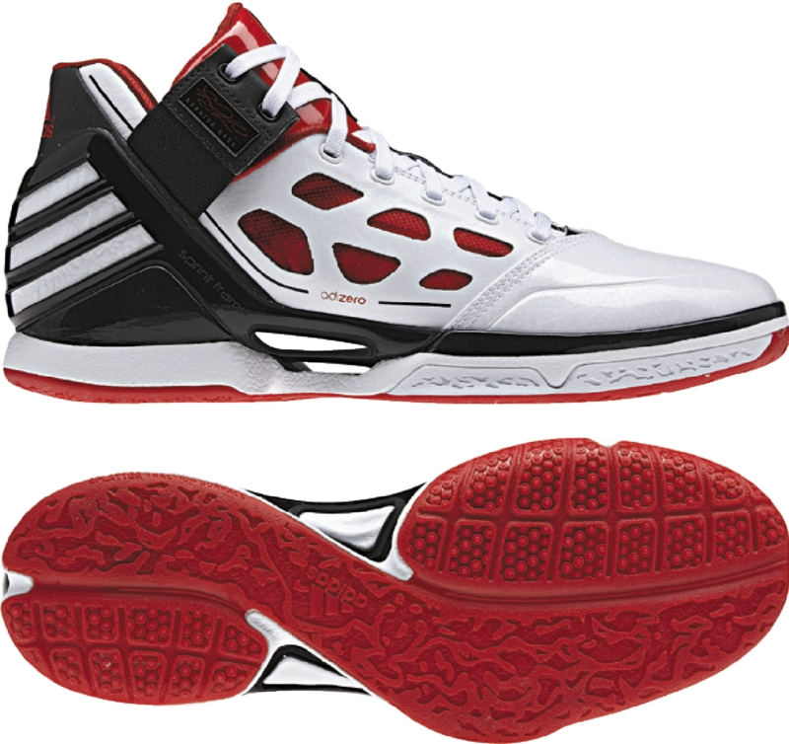

adiZero Rose 2 – Men’s Basketball

The youngest player ever to receive the NBA Most Valuable Player award, Derrick Rose steps into the adiZero Rose 2 by adidas for the 2011-2012 season. Light enough to take flight, SPRINTWEB technology allows Derrick to remain the fastest player in the game while the gore ankle strap keeps him secure on his path to the rim.

SIGNATURE DETAILS: “All Flights Cancelled” is the phrase stitched to the top of the tongue, displaying how Derrick’s on-court play altered the opposing teams’ chances for the upcoming season. The sockliner reveals a list of cities—all homes to professional basketball teams—in the same way destination cities are listed on an airport status board. All the statuses read cancelled except for one city that is cleared for flight—Chicago. The right side of the gore ankle strap features Derrick’s signature and the base of the tongue sports his number 1.

UPPER: Textile and synthetic materials in the upper work with the SPRINTWEB technology to provide support and comfort. The dynamic ankle lock system keeps the ankle secure in the shoe. There is a solid leather toe cap for off-court appeal.

MIDSOLE: SPRINTFRAME technology positions an external heel counter to reduce weight and allow for energy return and motion control. The molded EVA ensures the most lightweight midsole.

OUTSOLE: Unique herringbone and volcanic traction pattern give optimum grip and pay homage to Derrick’s explosive play.

WEIGHT: 12.4 ounces

SIZES: 6 – 15, 16 – 19
SRP: $110.00
PRODUCT ROLLOUT:

black/red/white – Away (G22887) October 6, 2011
white/red/black – Home (G22888) October 6, 2011

Will roll out in five additional colorways through December 22.

###

Contact:
Paul Jackiewicz, Global Basketball PR
971-234-2357 (o)
503-593-5316 (m)
Paul.Jackiewicz@adidas.com

